
QUALITY ALERT

Customer: ATI Date: November 13, 2023
Die: 15027D Colour: Any
Type of Complaint: ATI COMPLAINS

Q.A # Q.I.R # CUSTOMER NCR #

Description: ATI Complaints – Nailing Fin is too short makes it hard to install
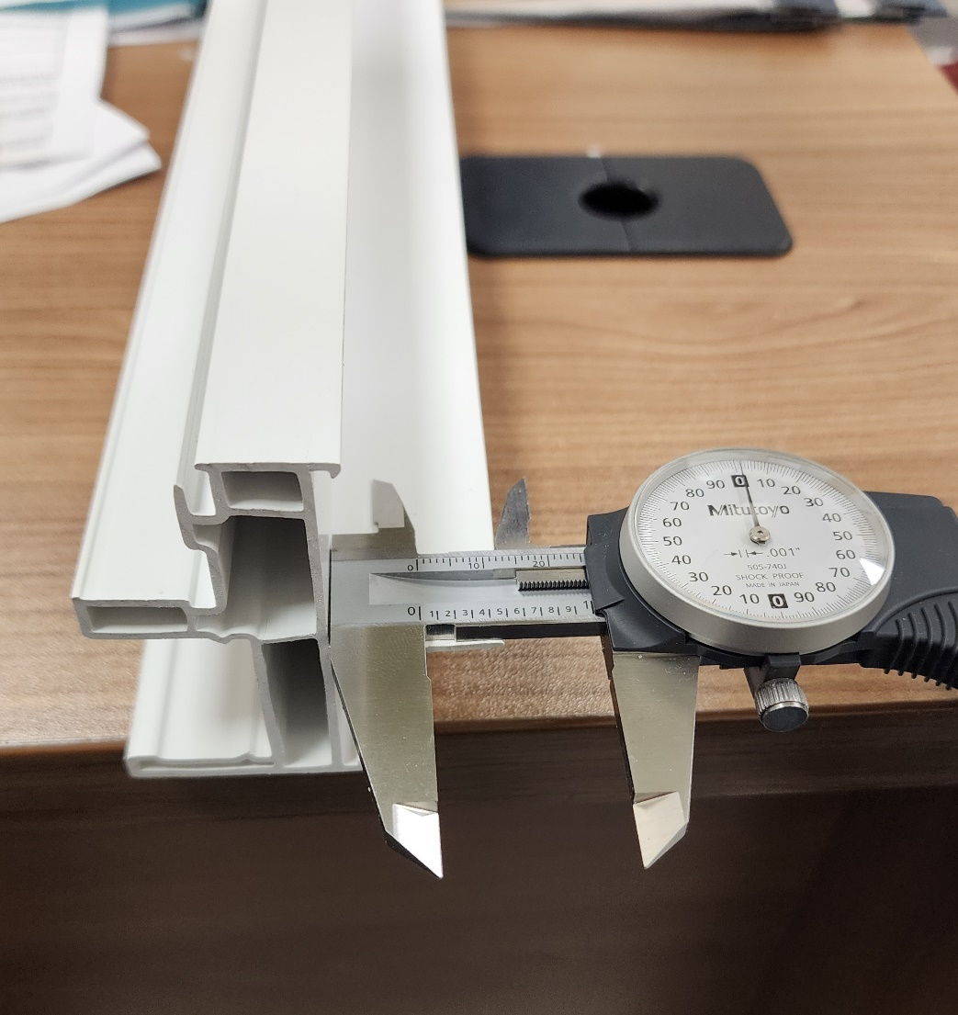
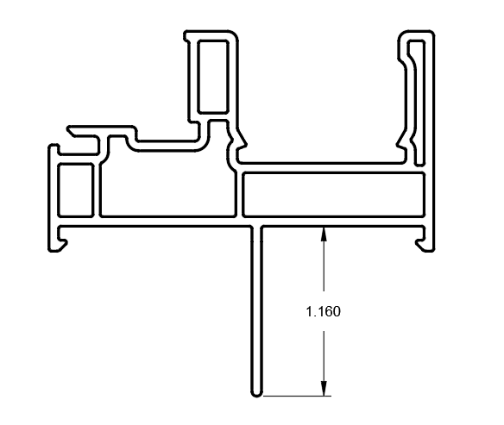
TOO SHORT

MAKE SURE THE FIN DIMENSION IS IN TOLERENCE ± 0.030”

BY SIGNING BELOW, YOU ACKNOWLEDGE THE PROBLEM ABOVE AND AGREE TO MONITOR THIS ISSUE IN FUTURE PRODUCTION RUNS.
DAY SHIFT |  | AFTERNOON SHIFT |  | NIGHT SHIFT
NAME | SIGNATURE | NAME | SIGNATURE | NAME | SIGNATURE

